2015 Holiday Schedule

Holiday Observance Day Day of the Week

 | New Years Day | January 1 | Thursday
 | Martin Luther  King Day | January 19 | Monday
 | Good Friday | April 3 | Friday
 | Memorial Day | May 25 | Monday
 | Independence  Day | July 3 | Friday
Rest & Relax | Labor Day | September 7 | Monday
 | Veterans Day | November 11 | Wednesday
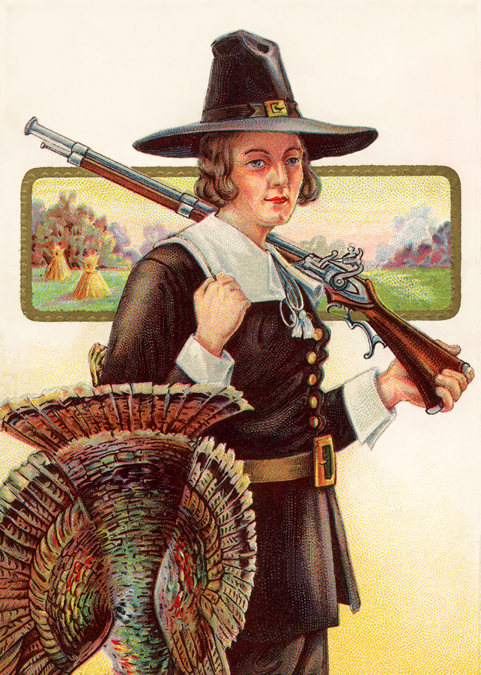 | Thanksgiving | November 26 & 27 | Thursday and Friday
 | Christmas | December 23, 24 & 25 | Wednesday, Thursday & Friday

